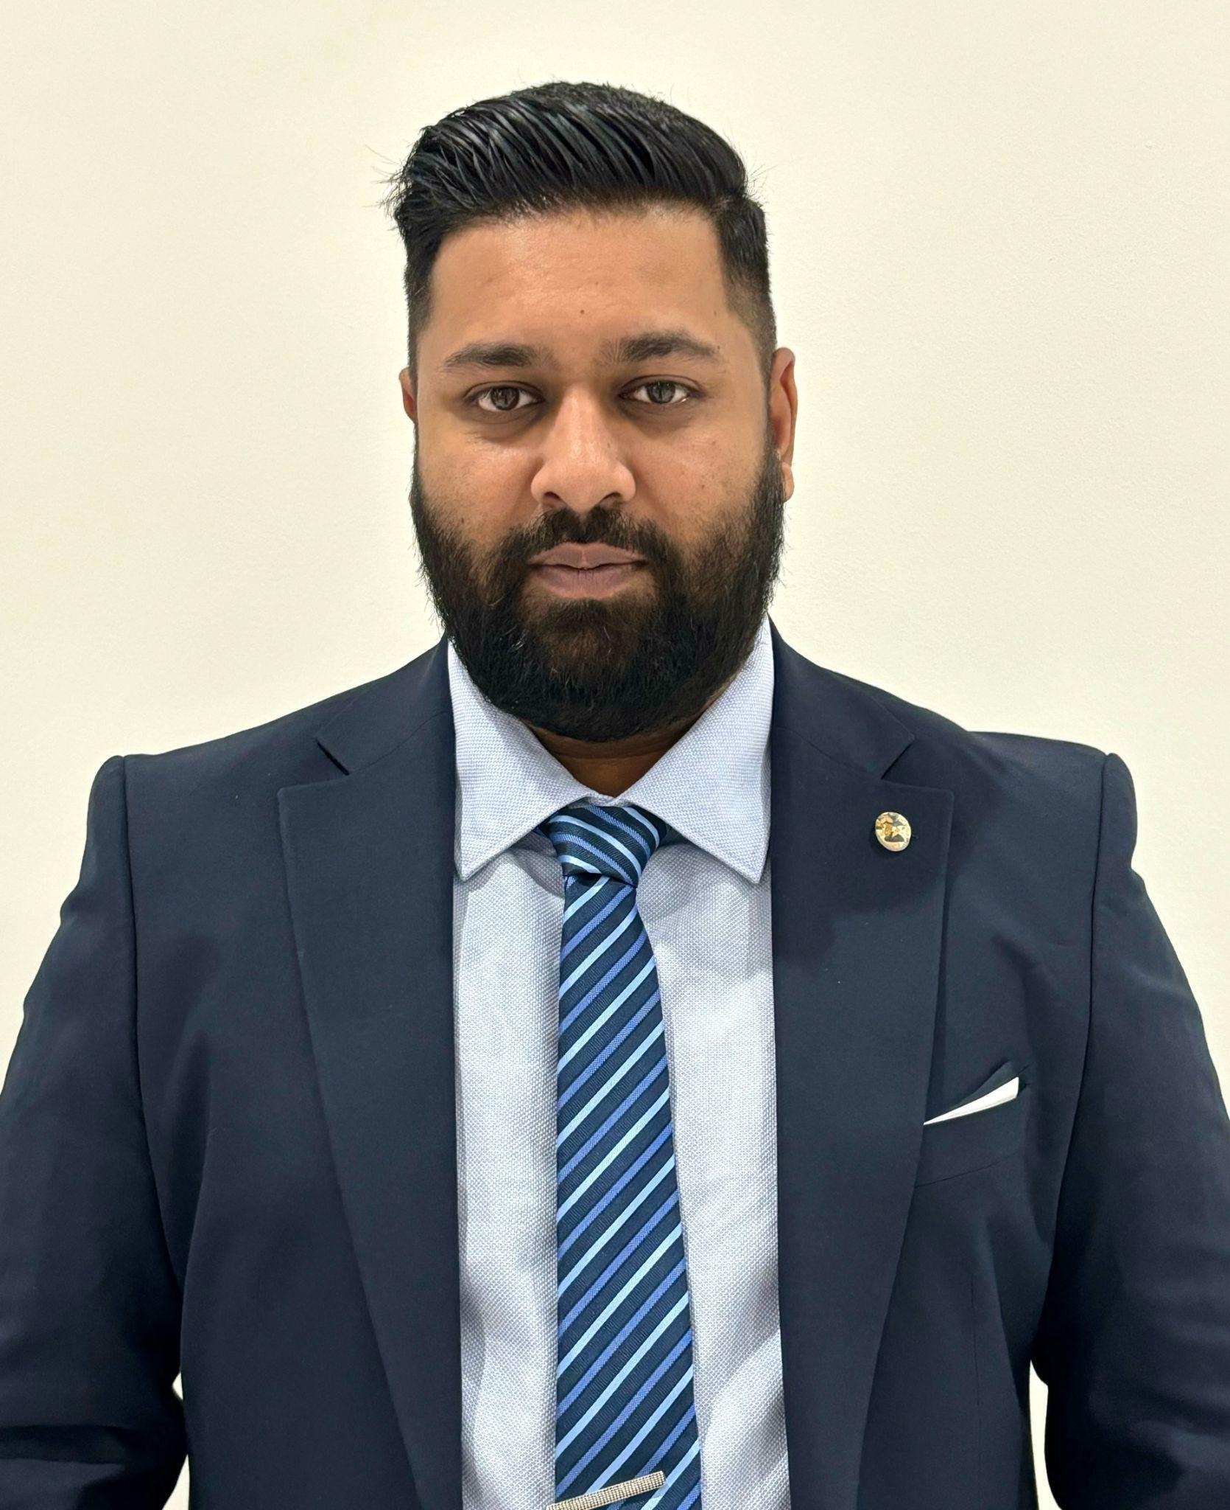
ROSTOM Muhammad Aniis Ibné Mustapha

90, Sir A R Mohamed Street
Plaine Verte, Port Louis.
(+230) 5987-8601 / (+230) 242-1540
aniisrostom@gmail.com

PERSONAL STATEMENT
With over 13 years of experience in the Mauritian financial sector, I am a versatile leader currently serving as the Chairperson of the Mauritius Meat Authority and Director of Alpha Business Solutions. My career progress—from a decade in core banking at SBI (Mauritius) Ltd to leading multi-jurisdictional investment support teams at Stonehage Fleming—is built on a foundation of operational excellence and strategic problem-solving. By combining my financial background with academic training in Communications and Marketing, I specialize in translating complex financial data into clear, stakeholder-ready insights. I am a past "Employee of the Year" winner dedicated to driving results through transparent communication, mentorship, and a commitment to service.

SKILLS
- Problem-Solving and Critical Thinking
- Communication Skills
- Teamwork and Collaboration
- Adaptability and Flexibility

EXPERIENCE

Mauritius Meat Authority - Chairperson (Part Time)
AUGUST 2025 - PRESENT

Alpha Business Solutions - Founder & Director
MAY 2025 - PRESENT

Stonehage Fleming - Team Leader - Investment Support (Mauritius, Monaco & Malta)
SEPTEMBER 2023 - MAY 2025

Stonehage Fleming - Senior Investment Support Officer
MARCH 2023 - AUGUST 2023

SBI (Mauritius) Limited - Senior Associate
JANUARY 2019 - MARCH 2023

SBI (Mauritius) Limited - Associate
MARCH 2012 - DECEMBER 2018
EDUCATION

BA Communications, Media & Journalism - Open University of Mauritius
JANUARY 2019 - NOVEMBER 2022
This degree greatly benefits me as a finance professional by honing crucial skills in effective communication, storytelling, and media literacy. This expertise enables me to articulate complex financial concepts to diverse audiences, engage stakeholders, and enhance public relations. The ability to convey financial information clearly and compellingly contributes to building trust, managing reputation, and navigating the intricacies of the finance industry.

Diploma Level 4 Marketing Management - The Association of Business Executives UK
JANUARY 2012 - MAY 2014
This diploma is invaluable for me as a finance professional as it imparts skills in strategic communication, market analysis, and consumer behavior. This qualification equips me to promote financial products effectively, tailor services to meet client needs, and enhance customer engagement. The acquired marketing acumen contributes to building a robust client base, fostering trust, and navigating the competitive landscape of the finance industry with a nuanced understanding of market dynamics

Cambridge A Level - Higher School Certificate - Islamic FVI College
JANUARY 2007 - NOVEMBER 2008

Cambridge O Level - School Certificate - Terre Rouge SSS
JANUARY 2002 - NOVEMBER 2006

AWARDS

Employee of the Year - SBI (Mauritius) Ltd
DECEMBER 2020

Best Mentor - Young Student Association
DECEMBER 2019

The Service Above Self Award - The Rising Association
DECEMBER 2016

